Things I am good at: | (Name)  (Photo)  (just right click the headshot and change picture)  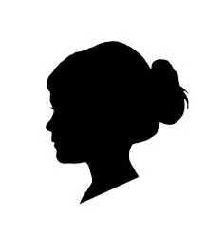 | My favorite things are:
Things that help me when I am stuck: | This summer I’ve been working on: | Things that are hard for me:
Things that help me stay regulated: | Things that calm me down:  Mom Cell:  Dad Cell: | My dislikes are:

